Jennifer Daniel

CIT480

Chapter 4 Exercises

**Exercise 4-1:**

4-1 Part 1:

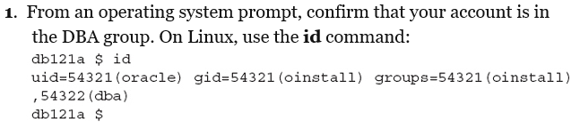



4-1 Part 2:

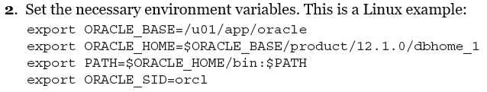

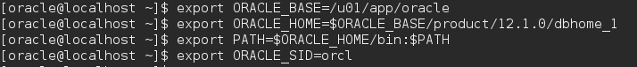

4-1 Part 3:

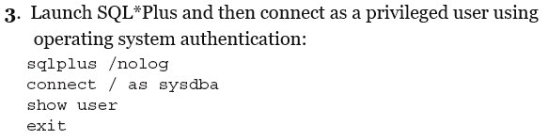

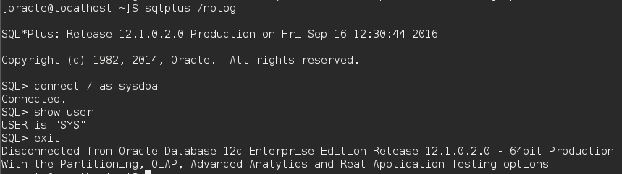

4-1 Part 4:

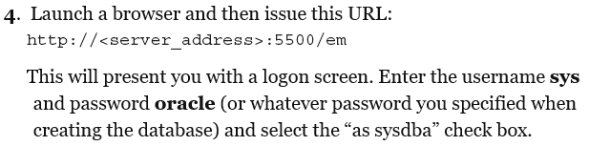

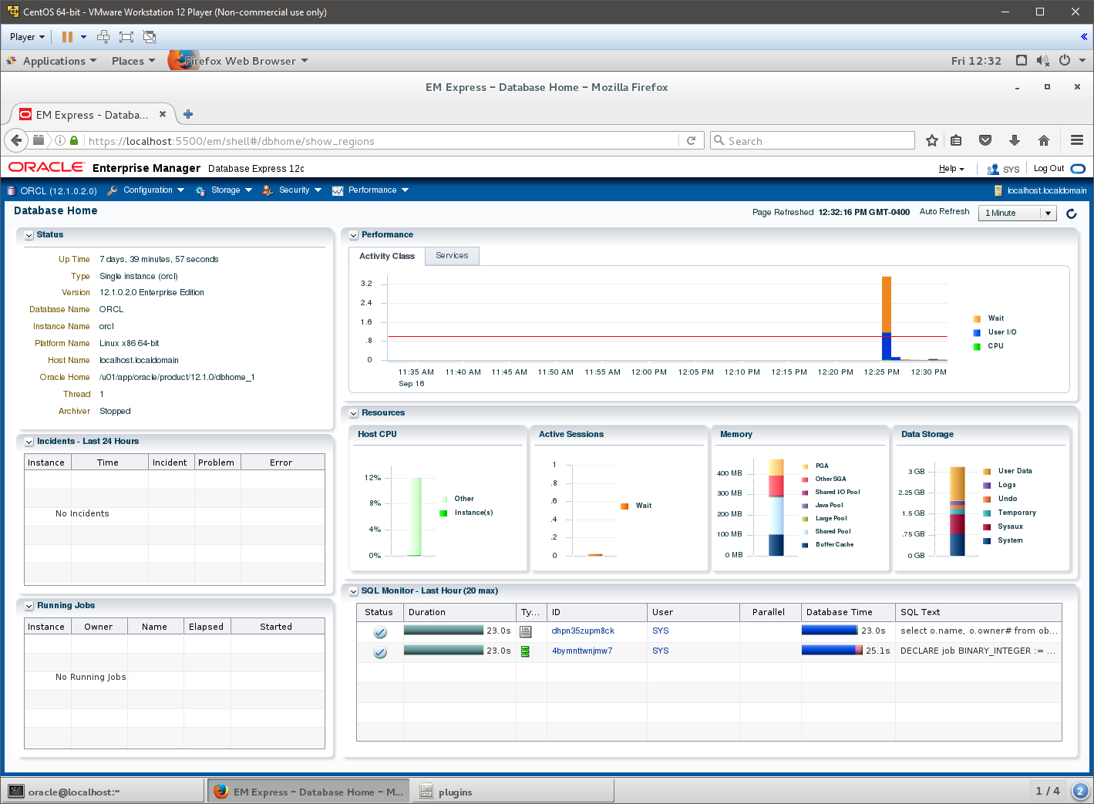

**Exercise 4-2:**

4-2 Part 1:

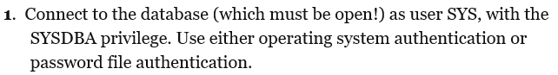

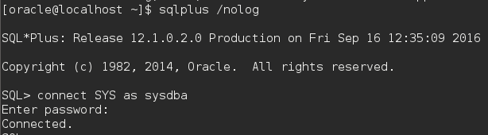

4-2 Part 2:

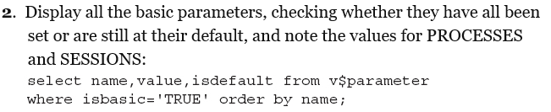

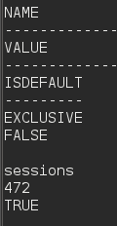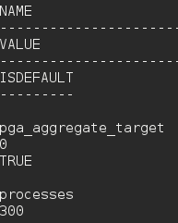

4-2 Part 3:

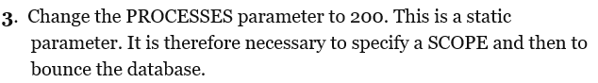

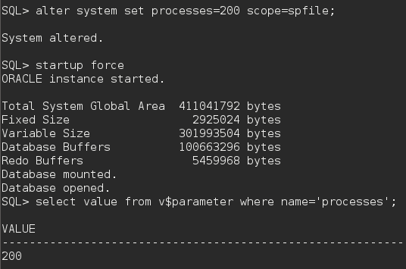

4-2 Part 4:

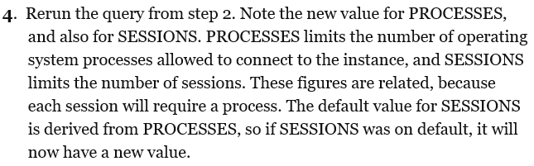

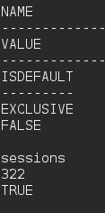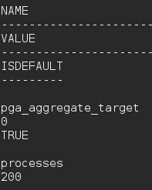

4-2 Part 5:

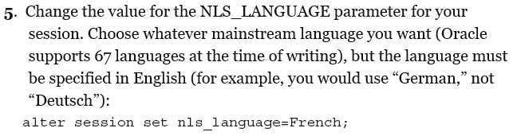



4-2 Part 6:

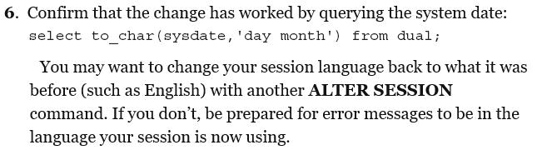

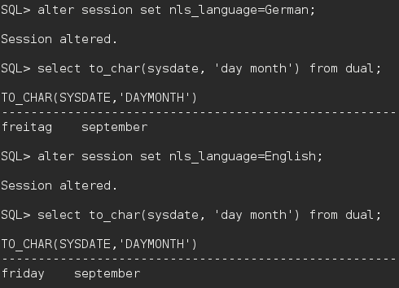

4-2 Part 7:

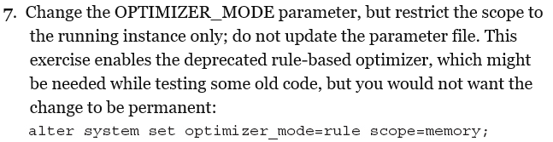

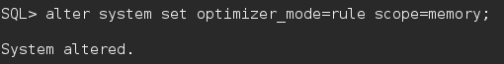

4-2 Part 8:

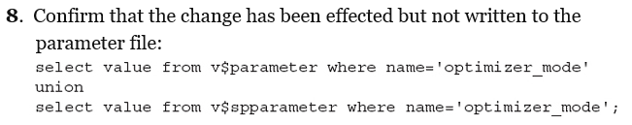

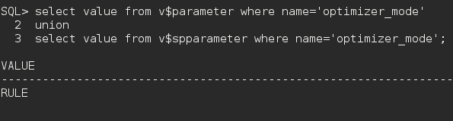

4-2 Part 9:

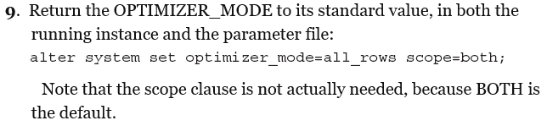

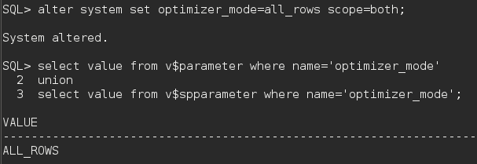

**Exercise 4-3:**

4-3 Part 1:

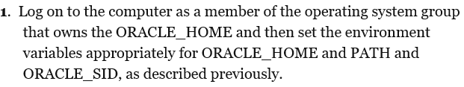



4-3 Part 2:



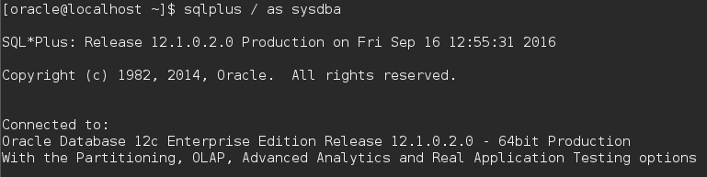

4-3 Part 3:



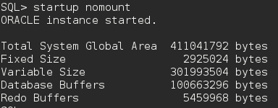

4-3 Part 4:





4-3 Part 5:





4-3 Part 6:



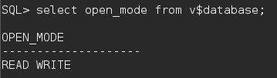

4-3 Part 7:



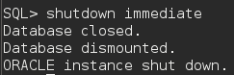

4-3 Part 8:

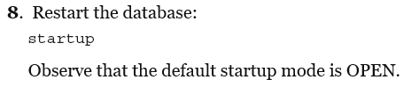

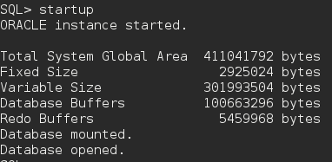

**Exercise 4-4:**

4-4 Part 1:



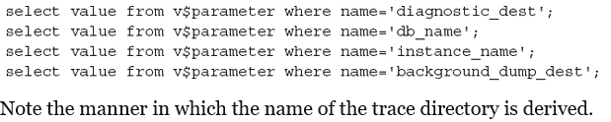

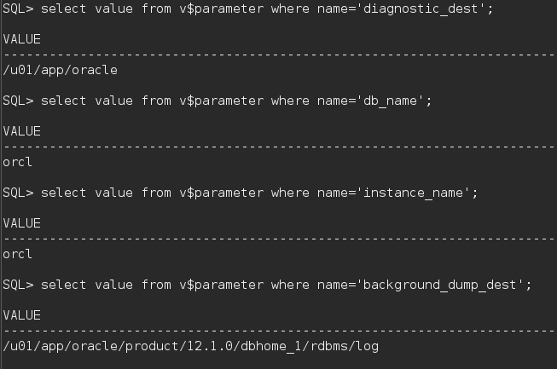

4-4 Part 2:

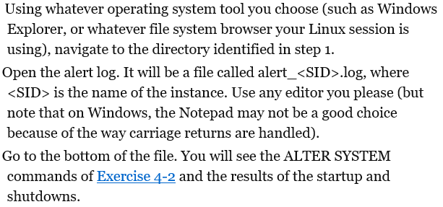

**Note: My system didn’t have this file.**

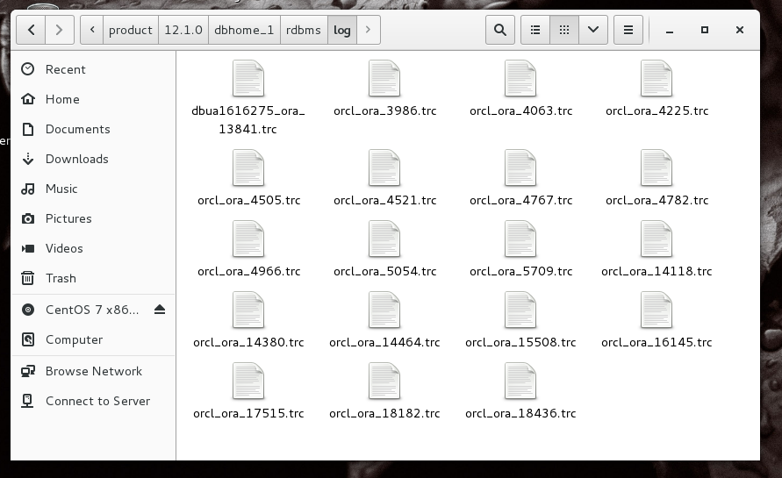

4-4 Part 3:

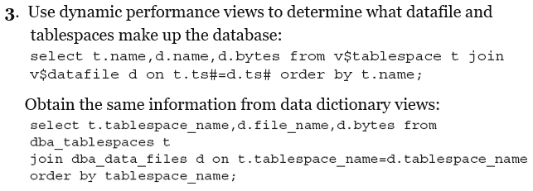

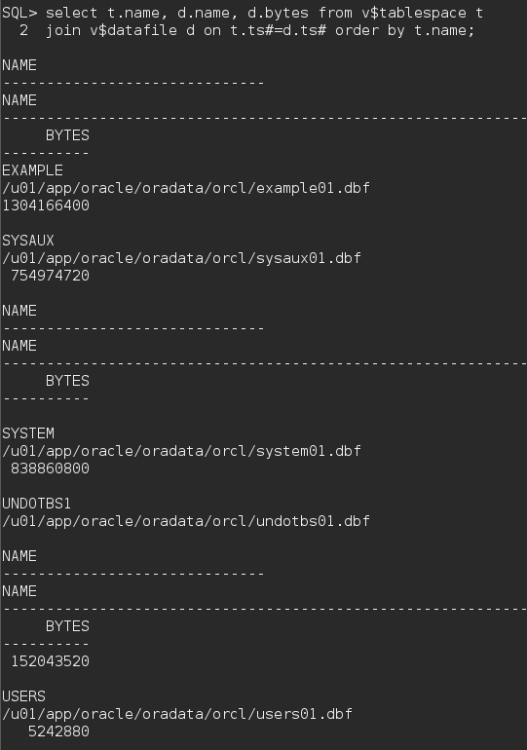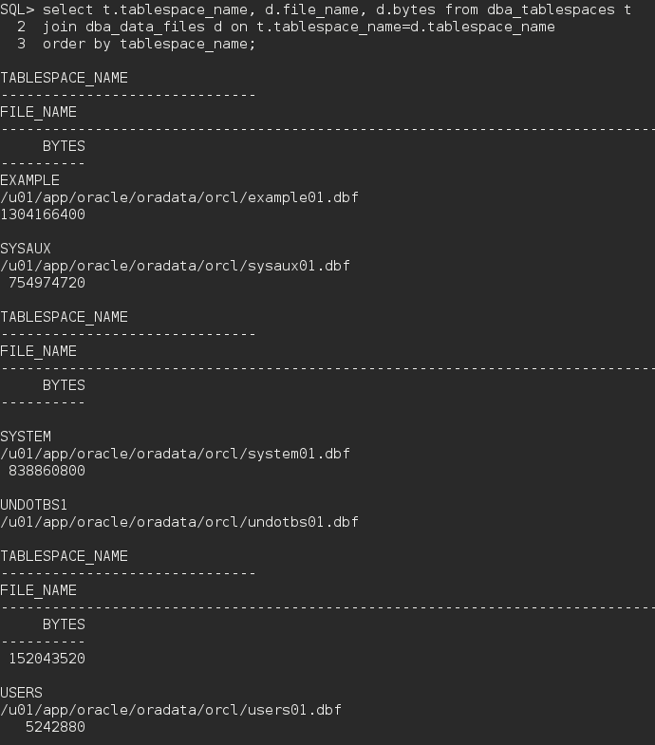

4-4 Part 4:

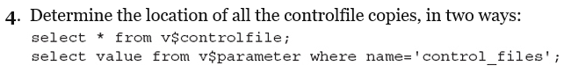

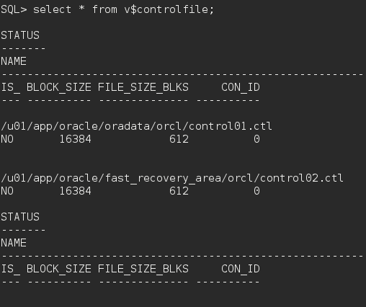

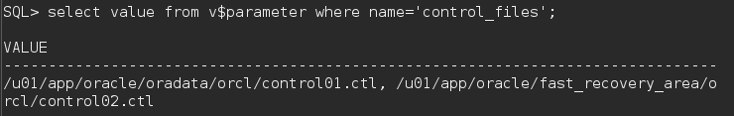

4-4 Part 5:

